RDZR-350X Transformer DC Resistance Tester

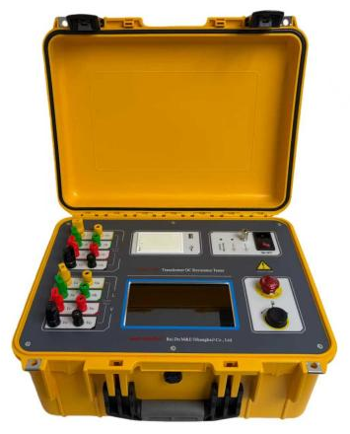
The DC resistance of transformer is a necessary testing item for the manufacturing, installation, handover, and preventive testing of transformers. It can effectively detect manufacturing defects and operational hazards such as looseness and breakage in coil material selection, welding, and connection parts. The RDZR-350X Transformer DC Resistance Tester developed by our company integrates magnetic assisted testing, three-phase testing (Yn, Y, △), and demagnetization functions. It is an ideal instrument for measuring the DC resistance of large power transformers. The instrument adopts a true color large screen high-resolution LCD display, supporting touch and rotary mouse operation. Menu prompt, easy and intuitive operation. All direct resistance testing projects can be completed in one wiring, with the advantages of fast testing speed, high accuracy, and wide range, which can meet the diverse testing needs on site.
- Product features

- The instrument supports three-phase measurement of Yn, Y, and △ windings and can automatically calculate the three-phase unbalance rate.
- Strong testing ability. The maximum output current of the power supply is 50A, with a measurement range of 0-25k Ω, covering the vast majority of transformer testing scenarios, and integrating magnetic assisted and demagnetization functions to meet the diverse needs of the site.
- Auxiliary judgment of data stability. During the testing process, the resistance value change rate within 5 seconds, 15 seconds, and 30 seconds can be automatically calculated to help testers avoid misreading data.
- Multiple security measures. It has functions such as 380V misconnection protection, back electromotive force protection, wire breakage protection, and power-off protection. At the same time, it has an alarm function for ungrounded grounding wire, which provides higher safety.
- Convenient data storage and output. Equipped with a thermal printer, this machine can store 200 groups of data and supports massive storage on USB drives, making it convenient for data retention and subsequent reference.
- Excellent human-computer interaction experience. Adopting an industrial grade 7-inch true color large screen, the display style is fresh and simple, with full touch and knob mouse operation, making the operation convenient and comfortable.
- Product specifications and technical parameters
Item | Description
Test current output | Single-phase: 50A, 20A, 10A, 5A, 1A, 0.2A, 10mA, <1mA  Three-phase: 25A+25A, 10A+10A, 5A+5A, 1A+1A, 0.2A+0.2A
Resistance measurement range | Single-phase:  75μΩ ~ 0.4Ω @50A 0.5mΩ ~ 1Ω @20A 1.0mΩ ~ 2Ω @10A 10mΩ ~ 4Ω @5A 0.1Ω ~ 20Ω @1A 1.0Ω ~ 80Ω @0.2A  50Ω ~ 2kΩ @10mA 500Ω ~ 25kΩ @1mA  Three-phase:  0.1mΩ ~ 0.25Ω @25A+25A 0.5mΩ ~ 0.6Ω @10A+10A  10mΩ ~ 1.5Ω @5A+5A 0.1Ω ~ 7.0Ω @1A+1A  1.0Ω ~ 30Ω @0.2A+0.2A
Accuracy | ±(0.2%rdg+2dgt)
Magnetic assisted | When the transformer adopts YN/y or YN/△ wiring, the low voltage side can use the magnetic assisted method for direct resistance measurement.
Demagnetization | Verify demagnetization. After demagnetization, the residual magnetization value of the transformer can be displayed
Display | 7.0-inch touch screen, resolution 1024×600
Storage | Local storage of 200 pieces of data, supporting FAT or FAT32 format USB extended storage
Printing: | Equipped with a thermal printer, supporting on-site printing of test results
Protection functions: | 380V misconnection protection, back electromotive force protection, wire breakage protection, power-off protection, and alarm function for ungrounded grounding wire
Power supply | AC220V±10%, 50/60Hz
Operating conditions | Temperature -10 ~ 50℃; Relative humidity<90%, no condensation.

